

**Green University of Bangladesh**

**Department of Computer Science and Engineering (CSE)**

**Faculty of Sciences and Engineering**

**Semester: (Spring, Year: 2022), B.Sc. in CSE (Day)**

**Course Title: Structured Programming Lab**

**Course Code: CSE 104 Section: 213-DE**

**Lab Project Name:** STUDENT RECORD MANAGEMENT SYSTEM

**Student Details**

|  |  |  |
| --- | --- | --- |
| **Name** | | **ID** |
| **1.** | Md Masud Rana | 213902101 |

**Submission Date: 10-05-2022**

**Course Teacher’s Name:** Md. Parvez Hossain, Lecturer of GUB.

**[For Teachers use only: Don’t Write Anything inside this box]**

|  |
| --- |
| **Lab Project Status**  **Marks: ………………………………… Signature: .....................**  **Comments: .............................................. Date: ..............................** |

Table of Contents

Chapter 1 3

Introduction 3

1.1 Introduction 3

1.2 Brief history of c 3

1.3 Features of C Language 3

1.4 Goals/Objective 4

Chapter 2 4

Implementation of the Project 4

2.1 Flow Charts 4

2.2 Implementation 6

2.3 Projects overview Screenshots 12

Chapter 3 16

Conclusion 16

3.1 Learning Outcome 16

3.2 Learning Outcome 16

# Chapter 1

# Introduction

## Introduction

The C Language is developed by Dennis Ritchie for creating system applications that directly interact with the hardware devices such as drivers, kernels, etc.

C programming is considered as the base for other programming languages, that is why it is known as mother language.

It can be defined by the following ways:

1. Mother language
2. System programming language
3. Procedure-oriented programming language
4. Structured programming language
5. Mid-level programming language

## Brief history of c

**History of C language** is interesting to know. Here we are going to discuss a brief history of the c language.

**C programming language** was developed in 1972 by Dennis Ritchie at bell laboratories of AT&T (American Telephone & Telegraph), located in the U.S.A.**Dennis Ritchie** is known as the **founder of the c language**.

It was developed to overcome the problems of previous languages such as B, BCPL, etc.

Initially, C language was developed to be used in **UNIX operating system**. It inherits many features of previous languages such as B and BCPL.

## Features of C Language

C is the widely used language. It provides many **features** that are given below.

1. Simple
2. Machine Independent or Portable
3. Mid-level programming language
4. structured programming language
5. Rich Library
6. Memory Management
7. Fast Speed
8. Pointers
9. Recursion
10. Extensible

## Goals/Objective

The goal of the project is to design student record management system .

To perform student record management system and find data easily.improving performance in student rocord system where we can manage student information in school,collage etc. we can update any information easily and we search any student record by id. We add student record nicely way and can manage all the students records. We can delete any record if need from system.

Easily everone can find their information by only student id. The user easily see how many student available in this file. The main goat of this project is store student data and find it by id and easily manage it.

To perform various operation in student record management system like student Add,delete,modify,search etc.

# Chapter 2

# Implementation of the Project

## Flow Charts

When the program is started, the user will direct to the main menu. The user will be required to select one of the seven options.

I have showed simple flowchart of this project . Below flowchart showed.

int choice

Read choice

Choice!=0

Create function

List all records function

Add function

Delete record function

Search record function

Modify record function

Number of records

End

Yes

No

## Implementation

**C source code**

1. #include<stdio.h>
2. #include<string.h>
3. #include<stdlib.h>
4. #include<conio.h>
5. void create();
6. void add();
7. void display_all_records();
8. void num_of_rocords();
9. void search();
10. void update();
11. void delete_record();
12. void decorationhomeWindow();
13. void decorationOthersWindow();
14. void decoration_on_list_all_students();
15. void decoration_on_searching_record();
16. typedef struct student
17. {
18. int id;
19. char name[30];
20. char dpt[10];
21. char section[10];
22. char cgpa[10];
23. char contact_number[15];
24. } student;
25. int main()
26. {
27. system("color 0a");
28. int choice;
29. do
30. {
31. decorationhomeWindow();
32. printf(" 1. Create \n");
33. printf(" 2. Add Student\n");
34. printf(" 3. List of All Students\n");
35. printf(" 4. Number of Records\n");
36. printf(" 5. Search Student Record\n");
37. printf(" 6. Modify Record\n");
38. printf(" 7. Delete Record\n");
39. printf(" 0. Exit\n");
40. printf("\nEnter your choice\n");
41. scanf("%d",&choice);
42. switch(choice)
43. {
44. case 1:
45. create();
46. break;
47. case 2:
48. add();
49. break;
50. case 3:
51. display_all_records();
52. break;
53. case 4:
54. num_of_rocords();
55. break;
56. case 5:
57. search();
58. break;
59. case 6:
60. update();
61. break;
62. case 7:
63. delete_record();
64. break;
65. }
66. }
67. while(choice!=0);
68. return 0;
69. }
70. void create()
71. {
72. system("cls");
73. FILE *fp;
74. student *s;
75. int num,i;
76. decorationOthersWindow();
77. printf("\nHow many student want to Create?: ");
78. scanf("%d",&num);
79. s = (student*)calloc(num,sizeof(student));
80. fp=fopen("StudentDB.txt","w");
81. for(i=0; i<num; i++)
82. {
83. printf("Enter ID: ");
84. scanf("%d",&s[i]);
85. printf("Enter Name: ");
86. fflush(stdin);
87. scanf("%[^\n]s",&s[i].name);
88. fflush(stdin);
89. printf("Enter Department: ");
90. gets(s[i].dpt);
91. printf("Enter Section: ");
92. gets(s[i].section);
93. printf("Enter CGPA: ");
94. //scanf("%f",&s[i].cgpa);
95. gets(s[i].cgpa);
96. printf("Enter Phone Number: ");
97. gets(s[i].contact_number);
98. fwrite(&s[i],sizeof(student),1,fp);
99. }
100. printf("File is create successfully\n");
101. fclose(fp);
102. system("cls");
103. }
104. void add()
105. {
106. system("cls");
107. FILE *fp;
108. student *s;
109. int num,i;
110. decorationOthersWindow();
111. printf("\nHow Many Student Want to Add?");
112. scanf("%d",&num);
113. s = (student*)calloc(num,sizeof(student));
114. fp=fopen("StudentDB.txt","w");
115. for(i=0; i<num; i++)
116. {
117. printf("Enter ID: ");
118. scanf("%d",&s[i]);
119. printf("Enter Name: ");
120. fflush(stdin);
121. scanf("%[^\n]s",&s[i].name);
122. fflush(stdin);
123. printf("Enter Department: ");
124. gets(s[i].dpt);
125. printf("Enter Section: ");
126. gets(s[i].section);
127. printf("Enter CGPA: ");
128. //scanf("%f",&s[i].cgpa);
129. gets(s[i].cgpa);
130. printf("Enter Phone Number: ");
131. gets(s[i].contact_number);
132. fwrite(&s[i],sizeof(student),1,fp);
133. }
134. fclose(fp);
135. system("cls");
136. printf("\nRecord is added Successfully\n");
137. }
138. void display_all_records()
139. {
140. system("cls");
141. student s1;
142. FILE *fp;
143. fp=fopen("StudentDB.txt","r");
144. decoration_on_list_all_students();
145. while(fread(&s1,sizeof(student),1,fp))
146. {
147. printf("\n %-13d%-22s%-12s%-10s%-10s%-10s\n",s1.id,s1.name,s1.dpt,s1.section,s1.cgpa,s1.contact_number);
148. }
149. fclose(fp);
150. }
151. void num_of_rocords()
152. {
153. system("cls");
154. student s1;
155. FILE *fp;
156. fp=fopen("StudentDB.txt","r");
157. fseek(fp,0,SEEK_END);
158. int num = ftell(fp)/sizeof(student);
159. printf("\nNumber of Records = %d\n",num);
160. fclose(fp);
161. }
162. void search()
163. {
164. student s1;
165. FILE *fp;
166. fp=fopen("StudentDB.txt","r");
167. int ID,found=0;
168. system("cls");
169. printf("Enter ID to search: ");
170. scanf("%d",&ID);
171. //system("cls");
172. decoration_on_searching_record();
173. while(fread(&s1,sizeof(student),1,fp))
174. {
175. if(s1.id==ID)
176. {
177. found=1;
178. printf(" %-13d%-22s%-12s%-10s%-10s%-10s\n",s1.id,s1.name,s1.dpt,s1.section,s1.cgpa,s1.contact_number);
179. // below another record showing structure.
180. // printf("ID: %-13d\nName: %-22s\nDepartment: %-12s\nSection: %-10s\nCGPA: %-10s\ncontact Number: %-10s\n",s1.id,s1.name,s1.dpt,s1.section,s1.cgpa,s1.contact_number);
181. }
182. }
183. if(!found)
184. {
185. printf("\n Record Not found!\n");
186. }
187. fclose(fp);
188. }
189. void update()
190. {
191. system("cls");
192. student s1;
193. FILE *fp,*fp1;
194. fp=fopen("StudentDB.txt","r");
195. fp1=fopen("temp.txt","w");
196. int ID,found=0;
197. printf("Enter ID to Modify\n");
198. scanf("%d",&ID);
199. while(fread(&s1,sizeof(student),1,fp))
200. {
201. if(s1.id==ID)
202. {
203. found=1;
204. printf("enter new name: ");
205. fflush(stdin);
206. scanf("%[^\n]s",&s1.name);
207. fflush(stdin);
208. printf("Enter Depertment: ");
209. gets(s1.dpt);
210. printf("Enter Section: ");
211. gets(s1.section);
212. printf("Enter CGPA: ");
213. gets(s1.cgpa);
214. printf("Enter Phone Number: ");
215. gets(s1.contact_number);
216. }
217. fwrite(&s1,sizeof(student),1,fp1);
218. }
219. fclose(fp);
220. fclose(fp1);
221. if(found)
222. {
223. fp1 = fopen("temp.txt","r");
224. fp = fopen("StudentDB.txt","w");
225. while(fread(&s1,sizeof(student),1,fp1))
226. {
227. fwrite(&s1,sizeof(student),1,fp);
228. }
229. system("cls");
230. printf("\n Record is Modified Successfully.\n");
231. fclose(fp);
232. fclose(fp1);
233. }
234. else
235. {
236. printf("Record is not found!\n");
237. }
238. fclose(fp);
239. }
240. void delete_record()
241. {
242. student s1;
243. FILE *fp,*fp1;
244. fp=fopen("StudentDB.txt","r");
245. fp1=fopen("temp.txt","w");
246. int ID,found=0;
247. printf("Enter ID to search\n");
248. scanf("%d",&ID);
249. while(fread(&s1,sizeof(student),1,fp))
250. {
251. if(s1.id==ID)
252. {
253. found=1;
254. }
255. else
256. fwrite(&s1,sizeof(student),1,fp1);
257. }
258. fclose(fp);
259. fclose(fp1);
260. if(found)
261. {
262. fp1 = fopen("temp.txt","r");
263. fp = fopen("StudentDB.txt","w");
264. while(fread(&s1,sizeof(student),1,fp1))
265. {
266. fwrite(&s1,sizeof(student),1,fp);
267. }
268. fclose(fp);
269. fclose(fp1);
270. }
271. else
272. {
273. printf("Record is not found!\n");
274. }
275. fclose(fp);
276. system("cls");
277. printf(" Record is Deleted successfully\n");
278. }
279. void decorationOthersWindow()
280. {
281. printf("\n\t\t\t###########################################################################");
282. printf("\n\t\t\t############ ############");
283. printf("\n\t\t\t############ Welcome to Student Record Add System ############");
284. printf("\n\t\t\t############ ############");
285. printf("\n\t\t\t###########################################################################");
286. printf("\n\t\t\t---------------------------------------------------------------------------\n");
287. }
288. void decoration_on_list_all_students()
289. {
290. printf("\n*********************** LIST OF ALL STUDENTS RECORD ************************\n");
291. printf("\n ID \t\tName \t\tDepartment Section\t CGPA\t Phone No.\n");
292. printf("----------------------------------------------------------------------------\n");
293. }
294. void decoration_on_searching_record()
295. {
296. printf("\n************************* LIST OF SEARCHING RECORD *************************\n");
297. printf("\n ID \t\tName \t\tDepartment Section\t CGPA\t Phone No.\n");
298. printf("----------------------------------------------------------------------------\n");
299. }
300. void decorationhomeWindow()
301. {
302. printf("\n");
303. printf("\n\t\t\t **-**-**-**-**-**-** -**-**-**-**-**-**-**-**-**-**-**-**");
304. printf("\n\t\t\t =-=-=-=-=-=-=-=-=-=-=-=-=-=-=-=-=-=-=-=-=-=-=");
305. printf("\n\t\t\t = WELCOME =");
306. printf("\n\t\t\t = TO =");
307. printf("\n\t\t\t = STUDENT RECORD =");
308. printf("\n\t\t\t = MANAGEMENT =");
309. printf("\n\t\t\t = SYSTEM =");
310. printf("\n\t\t\t = GREEN UNIVERSITY OF BANGLADESH =");
311. printf("\n\t\t\t =-=-=-=-=-=-=-=-=-=-=-=-=-=-=-=-=-=-=-=-=-=-=");
312. printf("\n\t\t\t **-**-**-**-**-**-**-**-**-**-**-**-**-**-**-**-**-**-**\n");
313. }

## 2.3 Projects overview Screenshots

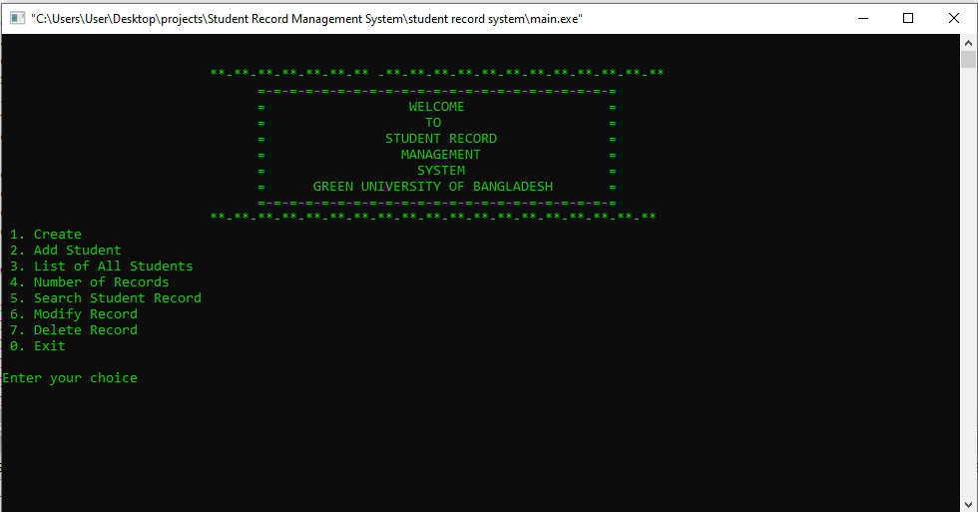

*Figure 1j: Main Menu interface*

When the program is executed, the user will be directed to the main menu interface. The program is introduced with a few lines of texts. Then seven selections are made for the user as the user can choose create , add student , list of all student or exit the program. If the user enter invalid options then this window again and again will be shown until the input is valid.

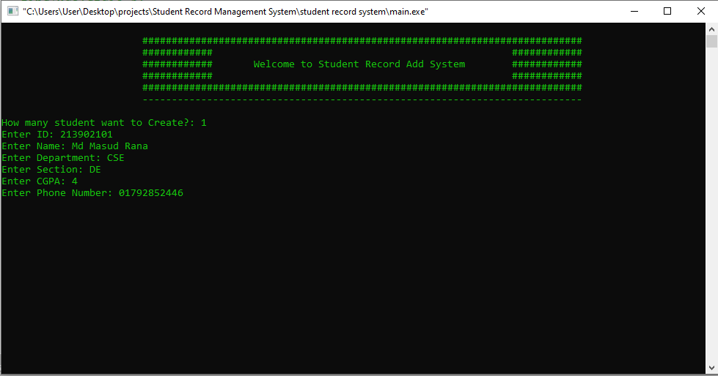

*Figure 2: create student record*

If the user enter 1, above interface will be shown to notify the user how many student want to add? If the user press 1 then user can add one record. Then user input name,depertment,section,cgpa and phone number.

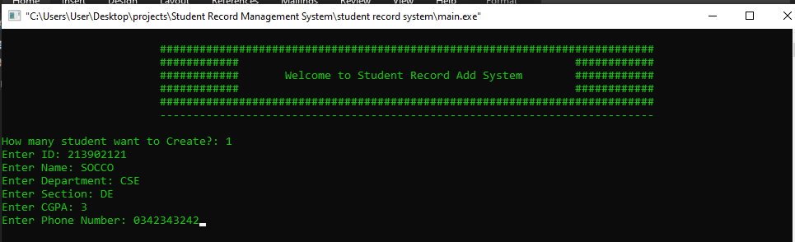

*Figure 3: add student record*

Similarly , If the user enter 1, above interface will be shown to notify the user how many student want to add? If the user press 1 then user can add one record. Then user input name,depertment,section,cgpa and phone number.

Student record will be added in the before created file. Mainly record will be added in exiting file that is previous created.

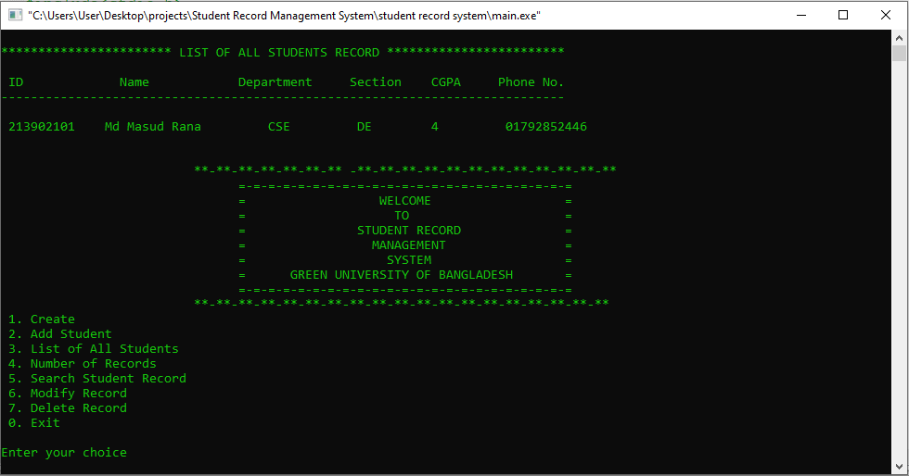

*Figure 4: list of all students records*

In the above photo shaws that if we want to show list of all record then we just simply press 3 for to show all record. If there is no record found then it showed empty file.

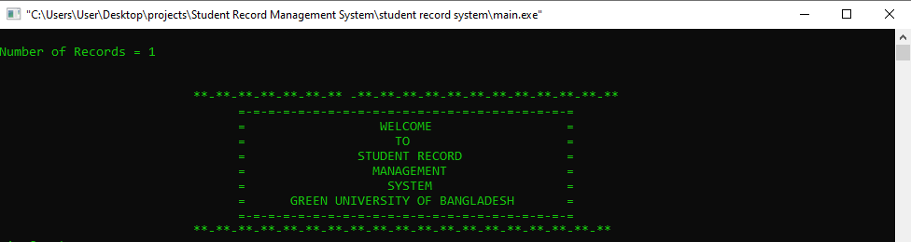

*Figure 5: Number of records*

In the above photo shows that how many records here. Since there is one record available so it is showed 1.

If there is no record available it shows “ Number of records = 0” . in the below I have attached photo.

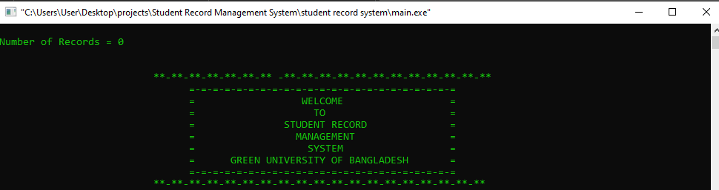

*Figure 6: Number of records are not available*

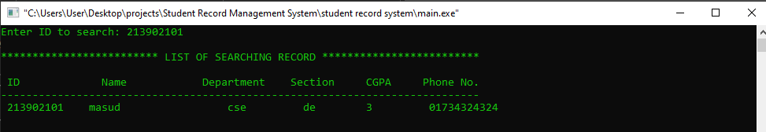

*Figure 7: it is displaying the searching record*

If we want to search specific record then we have to perform option five to find specific record by id. We have to input id actually what record want to search. After taking id id then we will see the above screen.

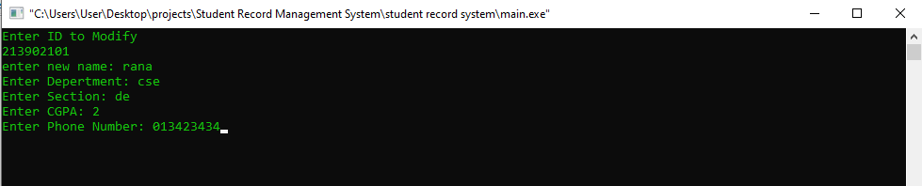

*Figure 8: Modify Record*

After perform the searching we can perform another option modify or update record by id. Here we add new name , depertment ,section,cgpa,and phone number by id.if id is valid then above screen will show and we can complete these tasks. After completing these task then record is updated and it show one message “ Record is Modified Successfully.”

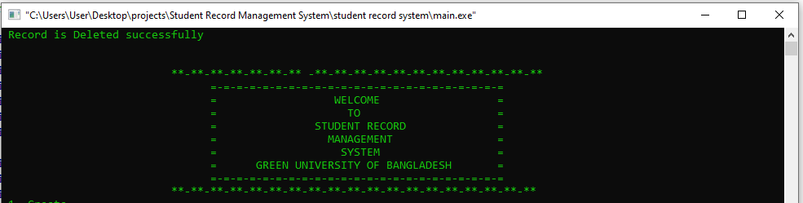

*Figure 9: Delete Rocord*

If user want to delete any record then simply press 7 and just input id. After iputing id and the id is valid then the record will be deleted and it shows a message like “ Record is Deleted successfully”.

# Chapter 3

# Conclusion

## Learning Outcome

The student record management system is design for users to manage record, add,create,search,find,delete and number of records. In this we learn many thing and something that is advanced topics like structure,typedef,pointer, file etc.

In this projects we perform “student rocord management” system in C”. this is a console application using the C programming language. This project compiled in Code Blocks with the GCC compiler in windows. In

this console application, I have completed basic Student Record tasks like create record,adding the student info, list all record, search the students,modify record,and delete rocord ..etc. This application based on file handling in C, where I haved used a file-related function like  fopen ,  fread ,  fwrite ,fscanf, fgets ,fputs ..etc function. i will use some

usedefined function like create();, add(), search(), delete(),modify();. to implement this projects we could manage student rocord system in school,collage etc. I have completed this projects using C technology and various tools. Mainly I have completed this projects in file handeling in c.i have used many built in and userdefied function,I have implemented it divided by many small blocks so that it readability increases and everyone can

edit and implementation it. From this projects I have learned these topics such as: operator, conditional, loop, array,string,pointer, structure,typedef,file handeling, and dynamic memory allocation. And something like this.

## Future scopes

* We can update more thing like student profile , student marksheet etc.
* We can add datastruture and algorithom to sort, edit, binary search,graph and linkdlist etc.,we can use graphics and dynamic programme